User’s guide to SMATR: Standardised Major Axis Tests & Routines

Version 2.0, Copyright 2006

Programmed by: Daniel S Falster¹, David I Warton², Ian J Wright¹
¹ Department of Biological Sciences, Macquarie University, NSW 2109, Australia.
² Department of Statistics, University of New South Wales, NSW 2052, Australia
Homepage: http://www.bio.mq.edu.au/ecology/SMATR/

Introduction
SMATR is a freeware program used for fitting bivariate lines to data and for making inferences about such lines. A line can be fitted using standardised major axis (SMA), major axis (MA) or ordinary least squares regression (OLS) techniques. The routines available in SMATR allow you to:
- fit lines to groups of data using SMA, MA or OLS methods
- construct exact confidence intervals around slope and intercept parameters and compare these to hypothesised values
- test for a common a common slope or elevation among lines fitted to several groups
- test for a shift along a common axis among lines fitted to several groups
- fit lines forced through the origin (appropriate for phylogenetic analyses)
- incorporate measurement error into parameter estimates.

Details about the use of these statistics and about the underlying formulas and their validation can be found in:

Warton, DI, IJ Wright, DS Falster, and M Westoby (2006) Bivariate line-fitting methods for allometry. Biological Reviews 81(2):259-291.

Table 1: Which method of line-fitting should be used, from Warton et al (2006)
Purpose | Key statistic | Appropriate method
Estimate the strength of the linear relationship between Y and X | r² | Correlation
Test for an association between Y and X | p | OLS regression
Predict Y from X (X may be fixed or random and may include measurement error; note that the latter situation is often erroneously used as a justification for use of SMA or related methods) |  | OLS regression
Predict Y from some underlying X that has been measured with error, so that only (X+δ) is observed |  | Method-of-moments regression
Estimate the line best describing the bivariate scatter of Y and X | 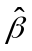 | MA or SMA
Test if the slope equals a specific value (1, or ¾ etc.) for the line best describing the relationship between Y and X |  | MA or SMA
Estimate the line best describing the bivariate scatter of Y and X, when only (X+δ_{X}) and (Y+δ_{Y}) are observed |  | Method-of-moments MA or SMA
Familiarity with this text (available at http://dx.doi.org/10.1017/S1464793106007007) is assumed prior to use of the program. The sections “Line-fitting methods and their uses” and “Regression, MA or what?” should be especially valuable for guiding the choice of an appropriate line fitting technique for your needs (summarised here in Table 1); advice is also given on the assumptions of each technique and how to check if these are satisfied.

The line-fitting techniques included all assume a linear relationship between Y and X:

Y = α + β X.

For allometric relationships, the observed variables (y, x) are believed to be related by the equation: y = γ.x^{β}. Conveniently this equation becomes linear after log-transformation:

log y = log γ + β log x.

In this case the scaling exponent in the allometric equation (β) is equivalent to the slope of the fitted line and scaling constant is related to the intercept by log γ = α. SMATR includes the ability to transform data (Log10, Ln) prior to analysis if required. Alternatively transformations can be run externally. Throughout this manual we refer to the fitting of a linear relationship between Y and X, where these variables may or may not have been transformed prior to analysis.

In some situations researchers may be interested in comparing bivariate relationships among two or more groups of data. The main purpose of this program is to provide a toolkit for researchers wishing to make such comparisons. Three relevant tests are possible (illustrated in Figure 1):

- Test for differences among two or more fitted slopes (shift A)
- If fitting a common slope can be justified (i.e., Test 1 is n.s.), test whether the fitted slopes share a common elevation (shift B)
- If fitting a common slope and elevation is justified, test whether the slopes fitted to each group are significantly separated along the common slope (shift C).

Figure 2 outlines the series of questions that can be asked to arrive at the various outcomes.

Figure 1: Schematic illustrating possible differences between bivariate lines fitted to individual groups of data. Each ellipse represents the region of graph space occupied by a given group.
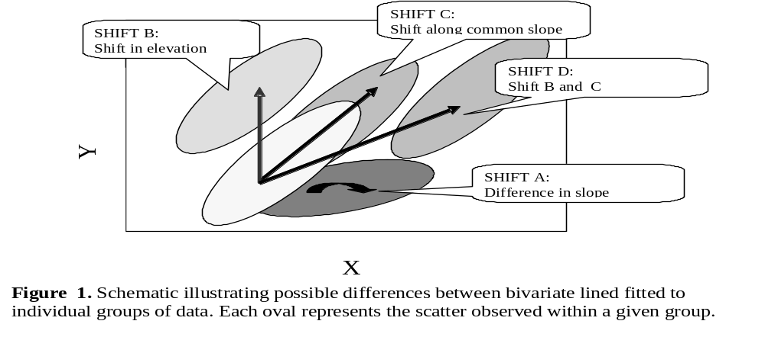

Figure 2: Schematic diagram illustrating the flow of logic in an investigation comparing bivariate relationships among two or more groups of data.

How many groups were compared?

SMA, MA or OLS fit?

Are assumptions satisfied?

yes

Is there a common slope?
(p > 0.05)

yes

no

Run comparisons for lines with common slope:
Compare residual scores R to test for a shift in elevation among groups (Shift B)
Compare fitted scores F to test for a shift along the common slope (Shift C)

Don’t run post-hoc multiple slope comparisons

Run post-hoc multiple comparisons to determine which groups differ

2

DONE:

Shift A

3 or more

DONE:

Test on R significant but not F → shift B
Test on F significant but not R → shift C
Test on F and R significant → shift D
Neither significant → no difference between groups

Is there a significant shift?

(p < 0.05)

How many groups were compared?

3 or more

2

no

yes

Run another comparison?

yes

no

Run post-hoc multiple comparisons to determine which groups differ

Instructions
The program is a DOS-based program designed to run in a PC Windows console. It can be run by double clicking from windows explorer, or via the Run command under the Start menu. The program can also be compiled to run in UNIX or Mac OSX operating environments.

A series of questions are asked of the user during operation. Questions either require yes-no answers or numerical input.

Input – data can be imported from file only. The file must:
- be in tab delimited text format
- be located in the same directory as the program itself
- include a single header line with variable names
- not include more than 1 blank line after data

Many variables can be present, including various grouping or filter variables. The file can include rows with missing data, but only where the missing data cell is blank, or has a single space character (standard Excel output). The file can have any name, but the default is for “input.txt”. There are no limits on variable name length, although short name are user-friendly.

Output – results are output to screen and file (tab-delimited text; default name “output.txt”). Only abbreviated results are printed to screen. If multiple procedures are run during a single session, new output is appended successively to the original output file unless a new file name is specified. Note that when the program is restarted, old output files with the same name will be written over. Output files can be opened in standard text editors (Notepad, WordPad) or in a spreadsheet such as MS Excel (recommended).

Program Flow – an opening menu prompts for information concerning input/output files, the number of iterations to be run, required confidence intervals, and other details (default settings shown in Fig. 3). The options are:
- Input file: enter name of data file
- Output file: enter name of file to store results
- Method: Choose to fit SMA, MA or OLS line
- Intercept: Option to force lines through origin (appropriate for phylogenetic analyses)
- Measurement Error: Specify whether estimates for measurement error will be included in line fitting (these must be obtained separately)
- Confidence Interval: Confidence intervals are given on slope and elevation estimates for individual groups, and for the common slope. The default 95% interval can be varied if desired (0-100%)
- Minimum group size: this sets the limit on the number of records below which entire groups are excluded from the analysis. The less “noisy” the data, the less data points are required for a “reasonable” slope estimate. If two variables are clearly unrelated (e.g., statistical significance of correlation is > 0.2 or 0.3), then it is unclear why one would be fitting a slope to the data anyway.
- Resample: Choose whether to use resampling procedure (default) or chi-squared distribution for common slope test
- Iterations: The number of permutations used in testing for common slope (more below). The recommended number of iterations is least 1000 if your critical level is p= 0.05, or 5000 if your critical level is p = 0.01 (Manly 1997) . You can always run more iterations, but the run time of the program will be longer. Beyond 10000 iterations measurement error will likely cancel out any increased resolution.
- Critical p-value: this determines the significance level below which a null result is rejected. This influences the construction of tables in post-hoc comparisons.
To save time in this menu, you can enter successive commands, separated by a space. E.g.
t 0 – change intercept option to no
t 0 m 0 o out.txt – above, OLS method plus change output file

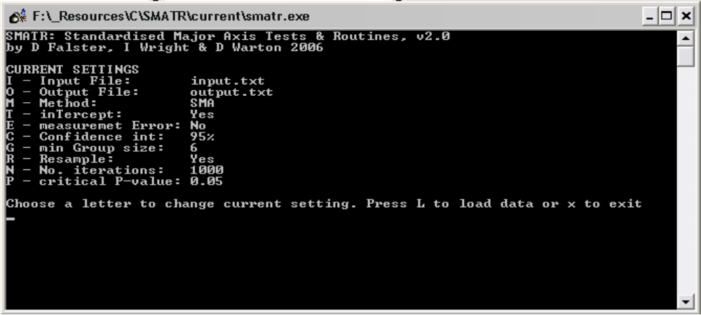

When satisfied with the settings for the above functions press L to load data. This opens a second menu that prompts for details of the test to be run:
- Variables: enter variable number not name
- Filter: one or more variables can be used as filters; these can be either categorical or scalar. Using filters allows multiple tests to be run without the need to create a new dataset for each test. Filters are specified AFTER loading the variables for analysis but before the analysis starts.
- Group: No grouping is necessary if you want to fit a line across all the data. If you wish to compare slopes, then at least one grouping variable must be included. Several variables may be selected in anyone test. NOTE: all subgroups will be compared directly; nested grouping structures are not possible.
- Transformation: if your data requires log transformation this can be achieved by choosing log transformation for either the X, Y or both axes. If your data is already log-transformed you should choose the default “linear” option.
- H0 slope: a value against which the fitted slopes for each group and the common slope (if one exists) are compared. This is useful if you wish to compare slopes against a specified a-priori value; however, this option does not affect other comparisons between groups.
- H0 intercept: a value against which the fitted intercept for each group is compared. This is useful if you wish to compare slopes against a specified a-priori value; however, this option does not affect other comparisons between groups.

To save time in this menu, you can enter successive commands, separated by a space, without pressing return, e.g.
g c – clears grouping variables
x 1 – selects variable #1 as the x variable
g c x 1 y 2 t 0– above, plus choose variable 2 for y and log-log transformation
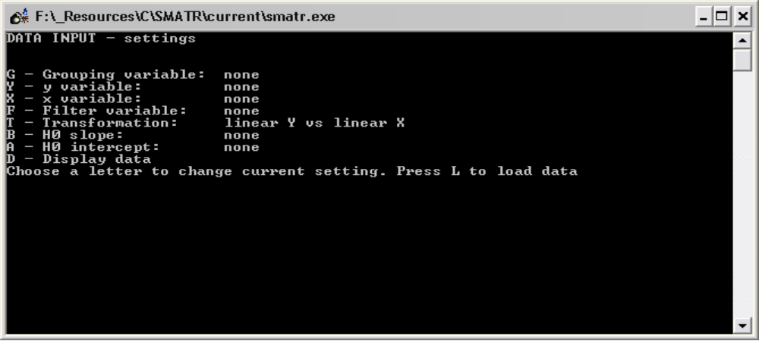

When ready, press L to load the data and run the common slope tests. Following this, you may be prompted with the following options, depending on whether you entered any grouping variable:
- Run post-hoc multiple slope comparisons among groups (if slopes were found to be significantly heterogeneous)
- Run comparisons for lines with a common slope (if slopes were not significantly heterogeneous).
You should consult in Figure 2 to determine which tests are necessary.

Eventually you will return to the initial menu screen. You can reload the same data and run an additional analysis by pressing L. Previously selected variables, groups and filter settings are stored between successive analyses to facilitate multiple analyses with similar data. However, if you change the filter variable in a subsequent analysis (e.g. add an extra filter), the filter options will need to be re-entered (you are prompted for this). In addition, if this filter was previously scalar, the transformed categorical values will be shown instead. Remember also, consecutive analyses will be appended to the same output file, unless a new name is specified.

File Output – full output details are only available in the output file (only some key results are shown on screen). Successive analyses in a given file are delimited by a line break. For each analysis the following is indicated:
- the x and y variables selected, including any transformations used
- the critical p-value, confidence intervals and number of iterations
- any filters variables used, including the relevant inclusion/ exclusion criteria (indicated in brackets: 1 = include, 0 = remove).
- the total number of data points included and removed (due to missing data or filters), and the name of groups with less than the minimum group size
- whether measurement error was included in line-fitting and the values used

SMA RESULTS
The next output summarises the SMA (or MA, OLS) lines fitted to individual groups, including:
- Group name, number of records, r², and a p-value. NOTE: r² and p are identical to those given when testing for a significant correlation between two variables
- The slope followed by the lower and upper confidence intervals on this value, and the estimated intercept followed by the lower and upper confidence intervals on this value.
- Ymean, Xmean – the average of the y and x values for each group
- (if relevant) H0_b, F, p: the output of a test comparing the estimated slope of each group to the specified value (H0_b), where F is the F-statistic for the test (with df =1, n-2), and p is p-value. p < p_crit indicates a value significantly different from H0_b
- (if relevant) H0_a, T, p: the output of a test comparing the estimated intercept to the specified value (H0_a), where T is the T-statistic for the test (with df =n-2), and p is p-value. p < p_crit indicates a value significantly different from H0_a

TEST FOR COMMON SLOPE ACROSS GROUPS
Next comes the estimated common slope and a p-value for a test of heterogeneity in slopes among groups. If p > p_crit , there is no evidence that the group slopes are heterogeneous and the common slope estimate can be used. In this case 95% confidence intervals and results of a test comparing the common slope to the hypothesised value (if appropriate) are given.

POST-HOC MULTIPLE COMPARISON OF SLOPES AMONG GROUPS
Post-hoc multiple slope comparisons are only offered where the test for a common slope indicates significant heterogeneity among groups (p < p_crit). The purpose of the post-hoc tests is to identify which groups differ from one another. This is achieved using the same procedures of estimating a common slope and testing for heterogeneity of slopes, as above, but including only two groups at a time. The output therefore consists of pairwise comparisons between groups, including:
- A matrix of individual pairwise comparisons. Data in brackets are the common slope estimate for the two groups, the test statistic and p value (df for all tests = 1)
- A second matrix listing p-values only
- A list of the groups ordered by slope, with p-values substituted for an asterisk if p > p_{crit}.

In interpreting the multiple comparisons of SMAs, a correction on the p-values may be required. This is because for any given test there is still some chance of reporting a significant difference between groups even though they do not really differ (Type I error; 5% for p_{crit} =0.05). When conducting many tests, the Type I error increases roughly proportionally to the number of tests. So, for example, when comparing 5 groups, there are 10 multiple comparisons, and at p_{crit}=0.05 there is about a 10 x 5% = 50% chance of incorrectly saying that two groups differ. Applying a correction to p-values is a way of keeping the overall (family-wise) Type I error low. Unfortunately, however, there is no single-best method for implementing this adjustment. A particularly conservative approach may be to apply a Bonferroni correction, although other more flexible techniques exist (Day and Quinn 1989). We have not provided any correction here, leaving this decision to the discretion of the user.

COMPARISON OF LINES WITH COMMON SLOPE
If there is a common slope then you may want to test for shifts in elevation or along the common axis among groups. These comparisons are made by comparing fitted (F) axis scores (shift along axis) or residual (R) axis scores (shifts in elevation); these measure the spread of data along (F) and away from (R) the fitted line. The test for group shifts in residual scores is analogous to the tests made in ANCOVA.

The initial output in this section indicates the common slope together with the grand mean (mean across all data points in all groups) of X, Y, fitted F and residual R scores. Following this a table is provided summarising the properties of individual groups:
- the intercept of the group: the intercept of the fitted line for each group, assuming the common slope. The equation for each line is then Y = intercept +β_{com}*X
- YgrandX: Provides the y value expected for each group at the grand mean of X. This is useful for making comparisons between groups at a common point
- XgrandY: as above, but for X
- Ymean, Xmean, Fmean, Rmean: the mean value of Y, X, F, R for each group.

Then comes output for tests comparing F or R among groups using the WALD test, including X² statistic and p-value. If p > p_{crit} then an estimate of common elevation or position along slope is also given (A_com). There is also an option to save the Fitted and Residual data to file for use in other tests. This file includes the initial plus the fitted and residual data. The number of rows may differ to your original dataset if missing cells or filtered data were removed.

Running post-hoc multiple comparisons
Following a significant shift in elevation or slope you can run post-hoc multiple comparisons to identify which groups differ (as for slope comparisons). This is achieved by comparing groups in pairwise manner using the WALD as above.

Statistical options

Measurement error
Measurement error (ME) will affect all slope fitting techniques. This can be accounted for by including estimates of ME in line fitting routines. The correction is necessary irrespective of what type of the line being fitted (OLS, SMA or MA). Use of SMA or MA does not overcome problems where both variables include ME (a common misunderstanding!).

Estimates of measurement error must be made separately for X and Y variables through repeated measures and calculated on transformed data (if relevant). See Warton et al (2006) pages 267 and 277 for more details. Note, these methods do not always perform well in small samples (see Appendix E in Warton et al. 2006). The standalone version of SMATR allows for use of a single estimate of ME for X and Y which gets applied to all groups. The version implemented in R allows for more detailed calculations, such as group specific estimates of measurement error and covariance.

ANCOVA vs SMATR
SMATR is primarily intended for making comparisons among lines fitted with SMA or MA routines. Routines for comparing OLS are also included, and should give reliable results, however; it is important to note that results from a test for common slope or elevation will not be identical to those obtained using ANCOVA. This is because ANCOVA assumes a common error variance and uses a different test-statistic.

Resampling vs Chi-squared: Significance for the common slope test can be determined either by resampling procedure or by comparison to chi-squared distribution. Usually, similar P-values will be obtained for these two approaches. The main exceptions to this are when data are grossly non-normal or when accounting for measurement error, in which case we recommend that resampling be used. The chi-squared distribution is known to be unreliable in these two situations.
Citation
Please credit the application and its authors in any published work that makes use of results from SMATR. The primary reference for the routines conducted by SMATR is:

Warton, DI, IJ Wright, DS Falster, and M Westoby (2006) Bivariate line-fitting methods for allometry. Biological Reviews 81(2):259-291.

You can also reference this program as an electronic publication using the following format:

Falster, DS, DI Warton, and IJ Wright (2006) SMATR: Standardised major axis tests and routines, ver 2.0. http://www.bio.mq.edu.au/ecology/SMATR/.

Distribution
SMATR is distributed under the GNU General Public Licence (June 1991; http://www.gnu.org/copyleft/gpl.html). This program is freeware, provided free of charge. You are welcome to use SMATR in any way for your own research, as long as such use is acknowledged as outlined above. By downloading and using SMATR, you are agreeing not to distribute SMATR in any commercial form.

No Warranty
The software described in this manual has no warranty, it is provided "as is". It is your responsibility to validate the behaviour of the routines and their accuracy using the source code provided. Consult the GNU General Public license for further details.

We encourage new users to check the programs homepage for the most recent version and lists of known bugs and fixes.

Support
Please refer to the references listed within this document for further statistical support. If you do not find the answer here, please check the program’s website for FAQs. The website also provides guidance on technical support and allows you to email requests for help.

Programming
SMATR is written in C++. The GNU Scientific Library ver 1.8 (http://www.gnu.org/software/gsl/) is used for matrix operations (Wald test), and to obtain p-values from known distributions. The windows version was complied using the Dev C++ v4.9 compiler for windows available at http://www.bloodshed.net/.

Most routines in SMATR are described in Warton et al. (2006). The algorithm for common slope tests were first presented in Warton and Weber (2002). Below are details on routines used in SMATR. Links to the relevant equations in Warton et al (2006) are as follows:

Routine | Source
Fitting lines to individual groups, calculating confidence intervals, inferences about slope and intercept | Table 4
Common slope test, CI for common slope | Appendix D
Significance test for common slope through resampling | Appendix F, (2)
Test for common elevation / shift along axis (WALD) | Appendix D
Line fitting with Measurement Error | Sec III, (3)
Line fitting forced through origin (for phylogenetic analyses) | Sec III, (4)

In addition, the following modifications (not mentioned in the paper) are necessary:

- when testing for common slope and forcing lines through the origin, replace ni -2.5 in Eqn 42 with ni-1.5
- when testing for a shift in elevation or shift along the slope with measurement error, the variance of residual and fitted scores are calculated as
Residual: s_{r}² = var(r) - (ME_{Y}+ b_{com}² ME_{X})
Fitted: (OLS) s_{f}² = var(f) - ME_{X}
(SMA) s_{f}² = var(f) - (ME_{Y}+ b_{com}² ME_{X})
(MA) s_{f}² = var(f) - (ME_{X}+ b_{com}² ME_{Y})
where ME_{X}, ME_{Y} are the measurement error prescribed to x and y.

References

Day, R. W., and G. P. Quinn. 1989. Comparisons of treatments after an analysis of variance in ecology. Ecological Monographs 59:433-463.
Manly, B. F. J. 1997. Randomization, Bootstrap and Monte Carlo methods in Biology, 2nd edition. Chapman & Hall, London.
Warton, D. I., and N. C. Weber. 2002. Common slope tests for bivariate structural relationships. Biometrical Journal 44:161-174.
Warton, D. I., I. J. Wright, D. S. Falster, and M. Westoby. 2006. Bivariate line-fitting methods for allometry. Biological Reviews 81:259-291.

